Email Capture Pro的使用者手冊

1. Email Capture Pro是設定與多功能印表機（Multi-Functional Printer，簡稱MFP）配合使用：當使用者從MFP掃描文件，並透過電郵系統傳送至其電郵時，DIKO會在發送的途中備份歸檔。要在DIKO裡作MFP相關的設定，請在「系統🡪 whenever someone scans from the printer (MFP) to the email address it will be filed to DIKO. To set up DIKO to use with MFP, go to System 🡪 SOP Email Capture Setup

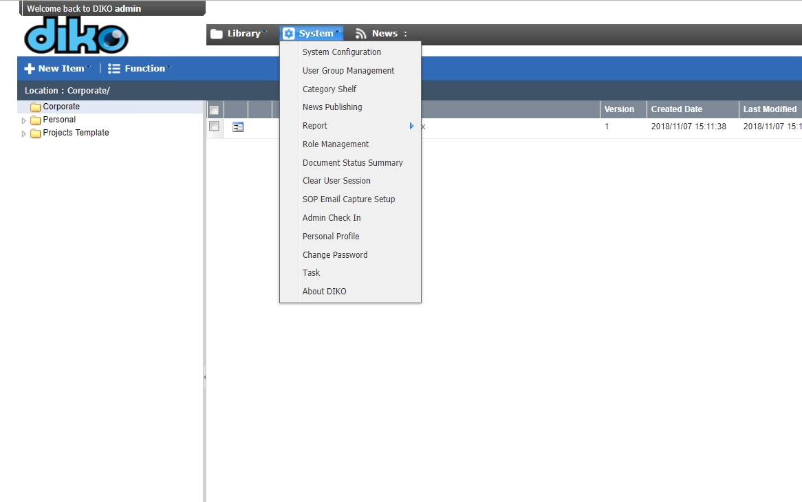

2. Email Capture Pro looks like this, click on "Add Inbox"

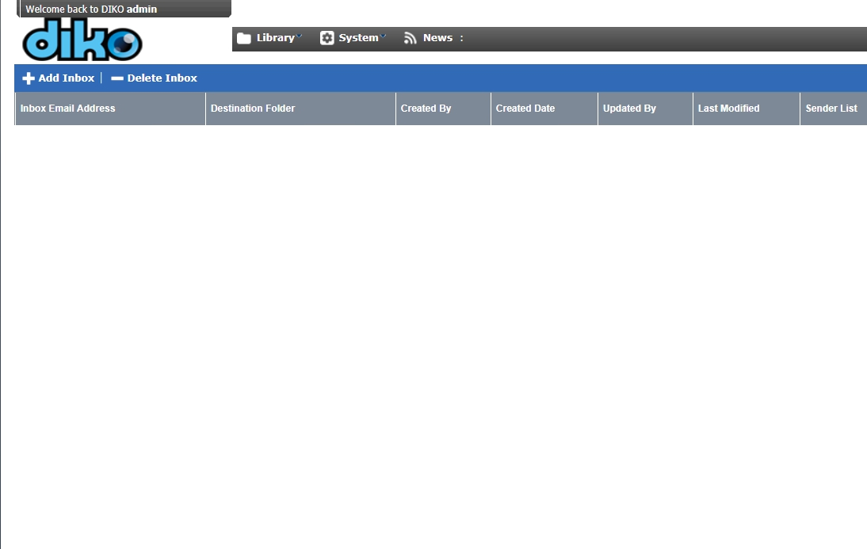

3. Fill in the information for the Receiving Inbox, also under Sender List you can choose who can send to the Receiving Inbox and have the emails filed to your desired folder path. Then click "Save" or "Update".

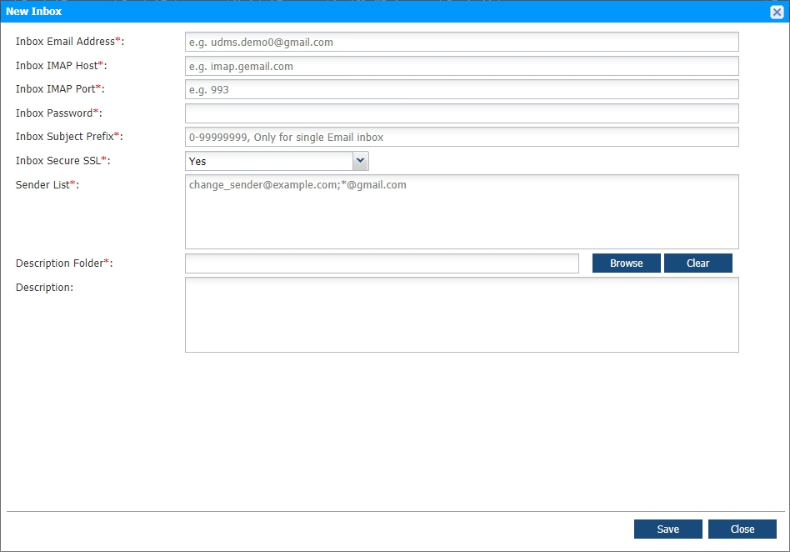

Make sure the destination folder does exist.  
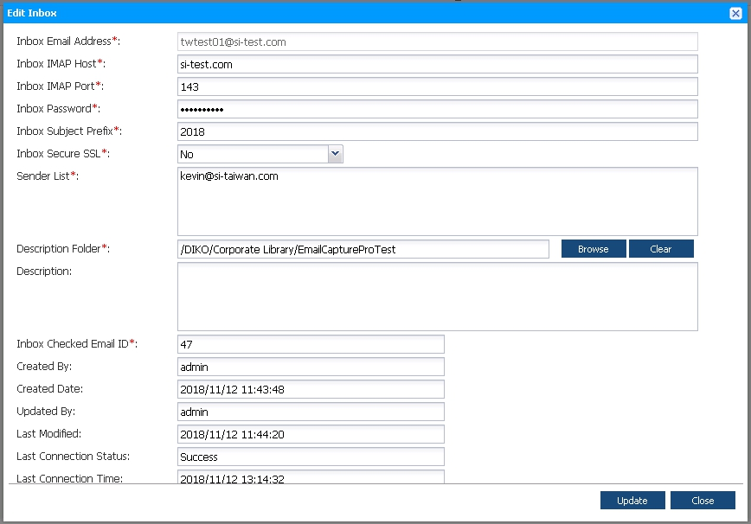

4. Send an email from the Sender List to the Receiving Inbox (Inbox Email Address)



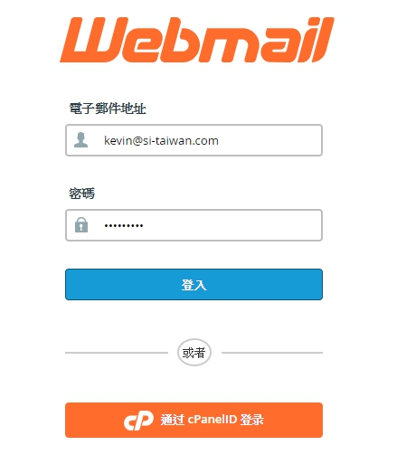

5. Sending mail to Receiving Inbox address with Subject, Message and a PDF attachment. (Must be PDF)

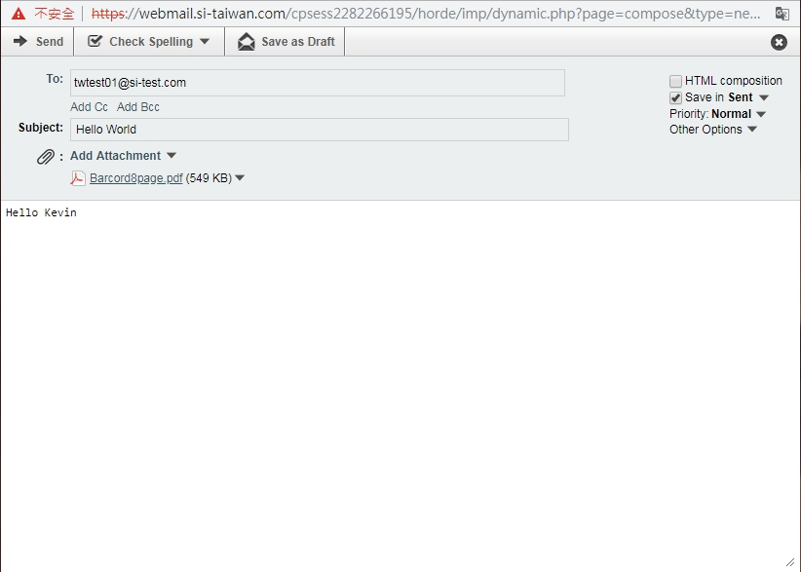

6. Received email from Sender List to Receiving Inbox, which is filed in the chosen path with the PDF attachment and message Subject, but no message content.

